
LEARNING AREA
Name:_________________________________________

Teacher: _______________________________________

Class: __________________________________________

CC Number: _____________________________

YEAR 8 EXAM

SEMESTER TWO 2015

SECTION ONE Resource Free

TIME ALLOWED FOR THIS PAPER
Reading time before commencing 2 minutes.
Working time for paper 18 minutes.

MATERIAL(S) REQUIRED / RECOMMENDED FOR THIS PAPER
TO BE PROVIDED BY THE CANDIDATE:
Standard items: pens, pencils, pencil sharpener, eraser, correction fluid, ruler, highlighters.

Important note to candidates:
No other items may be used in this section of the examination. It is your responsibility to ensure that you do not have any unauthorised notes or other items of a non-personal nature in the examination room. If you have any unauthorised material with you, hand it to the supervisor before reading any further.
TO BE PROVIDED BY THE SUPERVISOR:
This Question / Answer Booklet

Instructions to candidates
- Candidates are to remain seated during the exam and are not allowed to talk to other candidates.
- Mobile phones are not to be used at all during the exam.
- Students who fail to follow examination rules will be removed and dealt with in accordance to the schools policy.

Write your answers in the spaces provided in this Question/Answer Booklet. Spare pages are included at the end of this booklet. They can be used for planning your responses and/or as additional space if required to continue an answer.
- Planning: If you use spare pages for planning, indicate this clearly at the top of the page
- Continuing an answer: If you need the space to continue an answer, indicate in the original answer space where the answer is continued, i.e. give the page number. Fill in the number of the question(s) that you are continuing to answer at the top of the page.

Show all your working clearly. Your working should be sufficient to allow your answers to be checked readily and for marks to be awarded for reasoning. Incorrect answers given without supporting reasoning cannot be allocated any marks. For any question or part question worth more than two marks, valid working or justification is required to receive full marks. If you repeat an answer to any question, ensure that you cancel the answer you do not wish to have marked.

Use a blue or black pen only, except with diagrams where you should use pencil.

Question | Out of | Mark
1 | 4
2 | 3
3 | 3
4 | 2
5 | 3
6 | 2
7 | 3
TOTAL | 20
Your Mark | /20
Percentage

Question 1 [4]
a. Plot the following points on the given Cartesian Plane
(-9, -4) (-6, -2) (-3, 0) (0, 2) (3, 4) (6, 6)

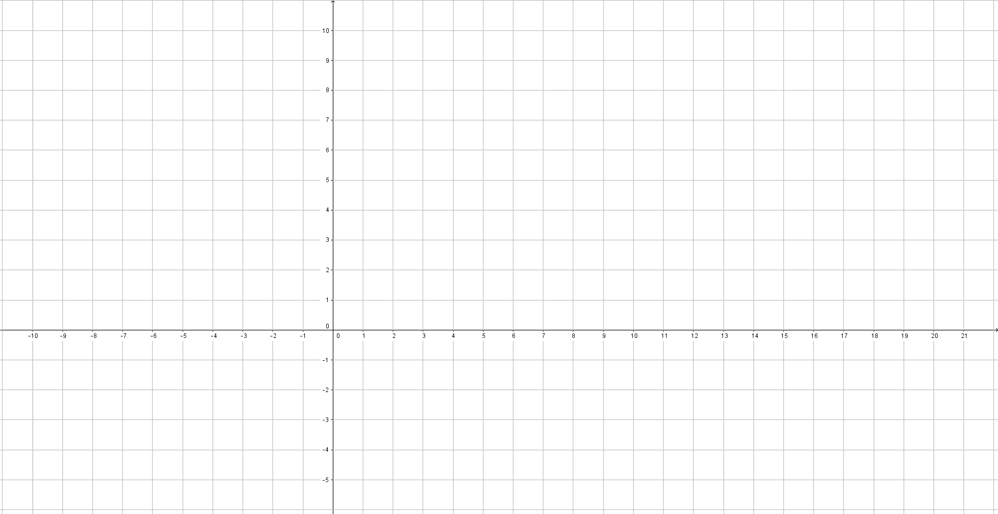

b. State whether the relationship is linear or non-linear.
Question 2 [3]
Plot the values in the following table on the axes provided

$$x$$ | -3 | -2 | -1 | 0 | 1 | 2 | 3
$$y$$ | -10 | -8 | -6 | -4 | -2 | 0 | 2

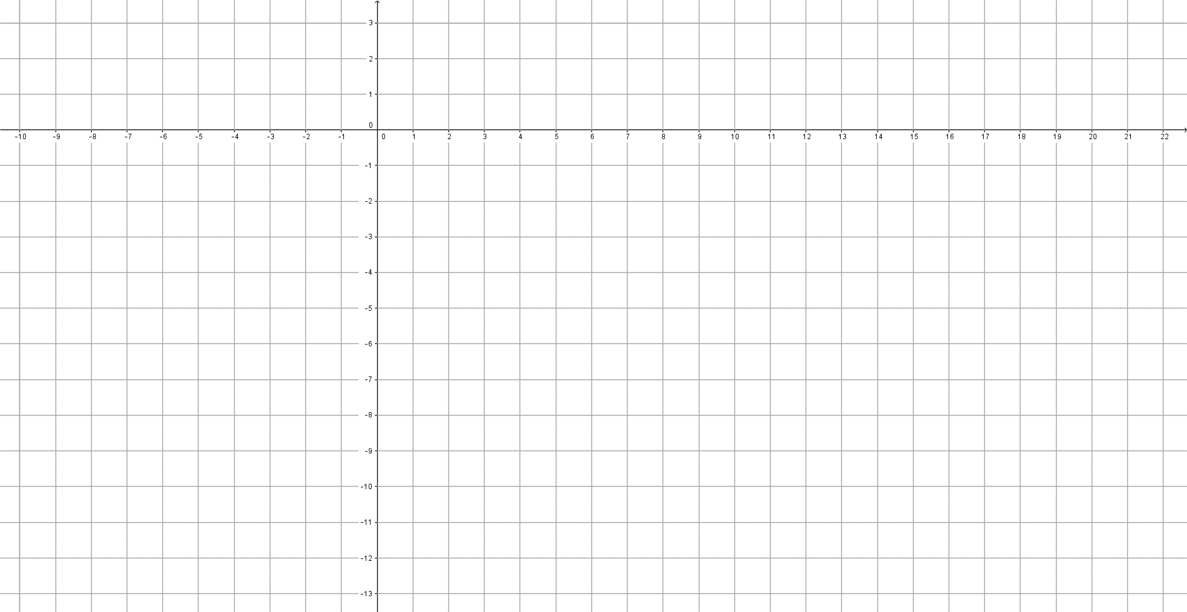

Question 3 [3]
Use the equation $y=3x+7$ to complete the table of values
$$x$$ | -3 | -2 | -1 | 0 | 1 | 2
$$y$$

Question 4 [2]
Give the equation for the following table of values

$$x$$ | 0 | 1 | 2 | 3 | 4 | 5 | 6
$$y$$ | 4 | 7 | 10 | 13 | 16 | 19 | 22

Question 5 [3]
Give the equation of the graph shown 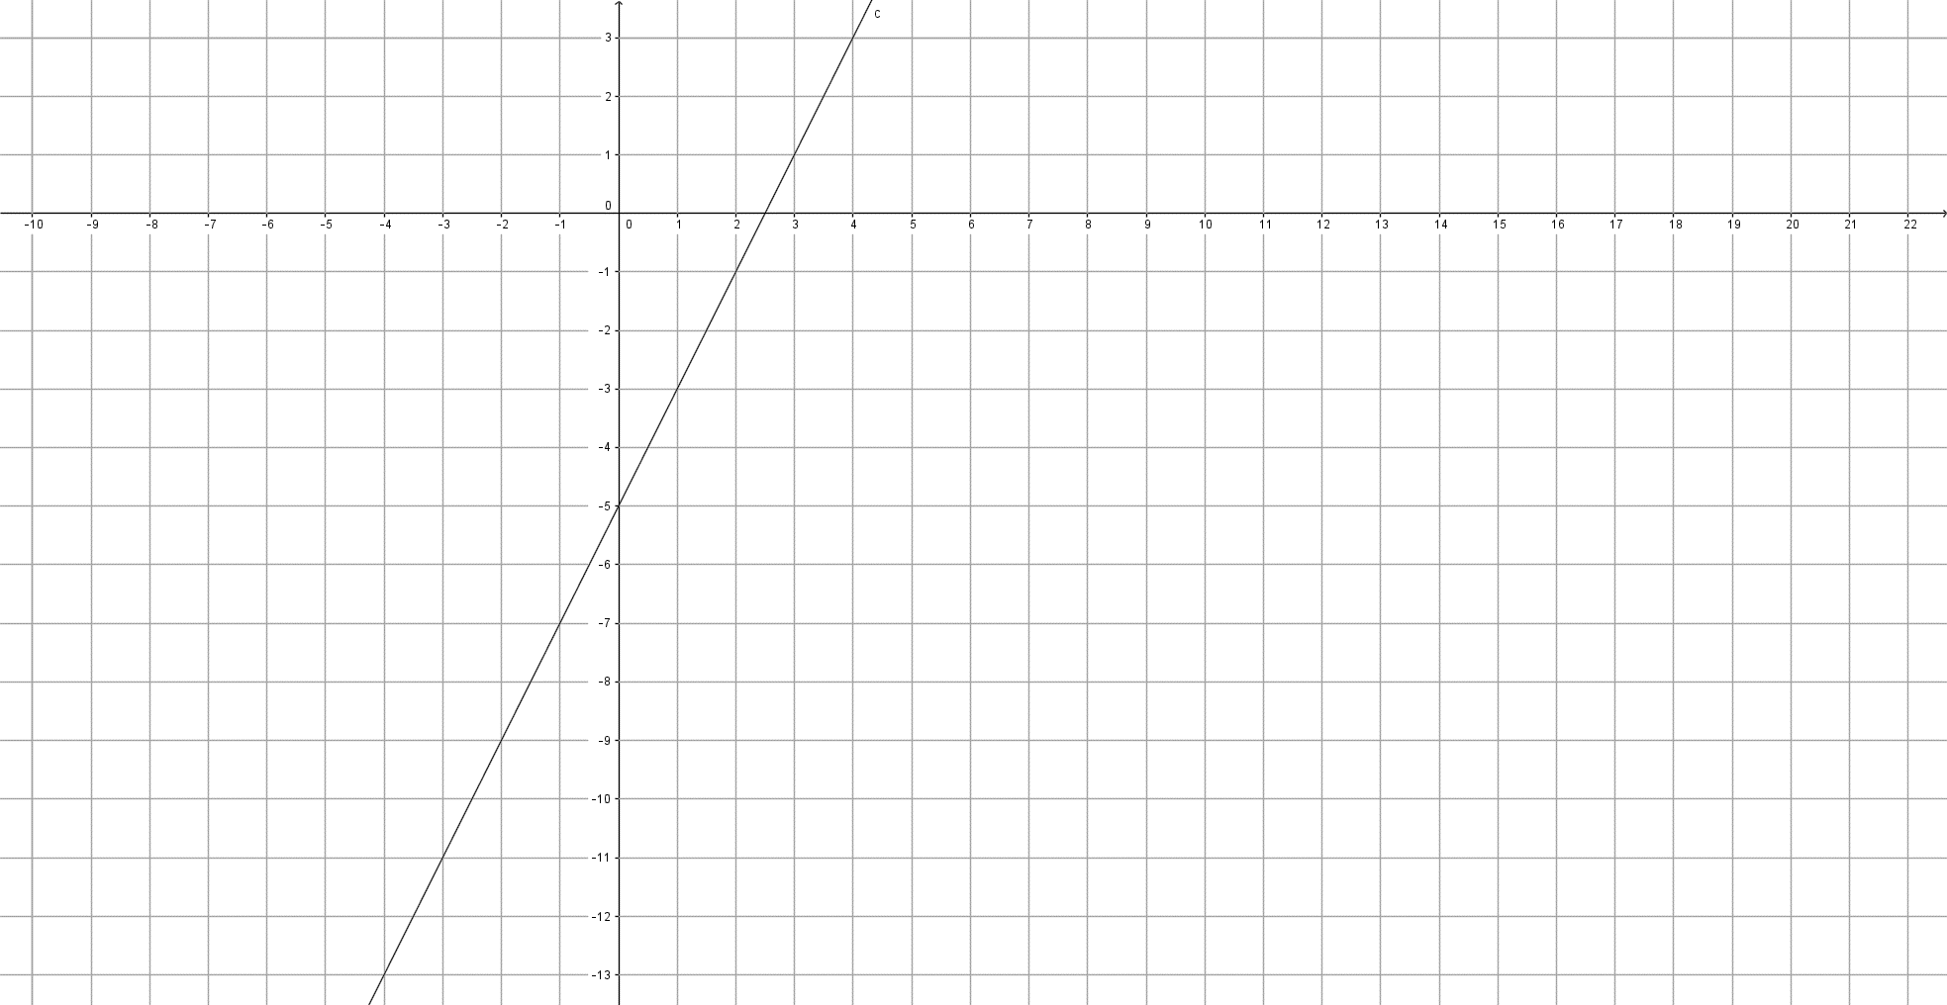
Gradient:
Y intercept:
Equation:
Question 6 [2]
Sketch the graph for the equation $y=2x+3$



Question 7 [3]
An aeroplane climbs 200m for each 40m it covers as it takes off from Jandakot airport. What is the gradient of its take off?
Hint: a diagram may help you

